PLAETNER
ON YOUR PLATE

Audio_video installation by Ane Mette Ruge.
In posthumous dialogue with Danish electronic composer Jørgen Plaetner(1930-2002)
In cooperation with Emil Alenius Boserup

The ambiguous question of the phrase What’s on your plate, referring to the size of the everyday workload of the corporate employee, can be said to have been a lifelong source of frustration for the Danish pioneer of electronic music, Jørgen Plaetner. Being ahead of his time, his work was overshadowed by other composers, who according to Plaetner did not understand the first thing about the greatness of electronic composition.

The installation:
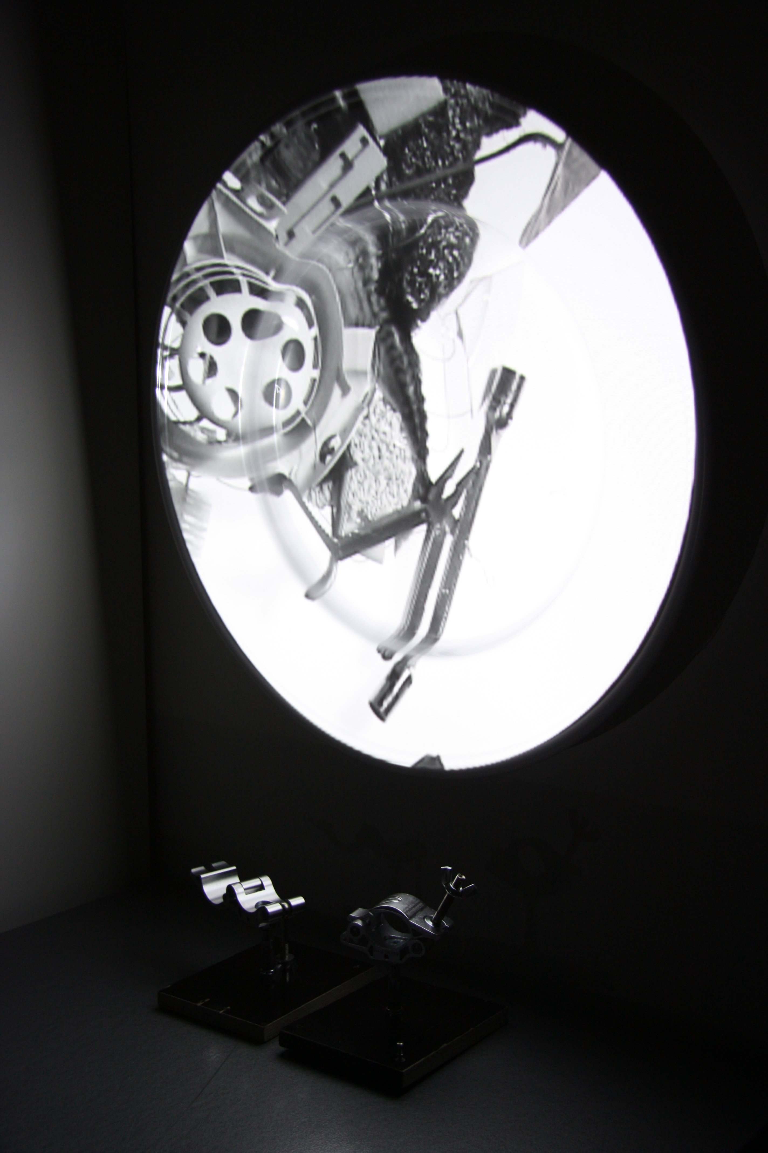
Projected onto a large discarded satellite dish, is a B/W animated film sequence showing a selection of word-objects and everyday objets trouvés, namelessly lost to entropy, and obviously removed from the logic of functionality.The objects are involuntarily intertwined and moulded into one mass, physically interconnected by and stuck in lengths of metal wire.
On your plate_01
Projection sketch on vacuum moulded dinnerplate. 80cm Ø/acrylic. 2011
Edited to merge and be intimately intertwined also with the soundtrack of the Pleaetner/Borum/Ernst POEX65 live performance, the objects alternately emerge from no-where, landing on the dish, and alternately they take off and tumble back into the void.
From another audio source in the exhibition space a selection of accentuating sounds are added, in order partly to supply opportunity for absolute synchronity in certain moments of the filmic sequence, and partly in order to underscore the sculpturality of the coming and going of the abstract objects, which are being exchanged back and forth via the dish, but across decenniums in an entropic narrative.

